Switched 12 V Lab
Seth Ricks
ECEN 350
11/21/2025

ECEN 350 – Switched 12 V Lab (50 points)
(jas, Switched 12 V Lab.docx, 7/26/2025)

Note: You can work in pairs if desired on this lab, although no three person teams are allowed. Submit an electronic version of a lab report to receive credit for doing this lab. The goal of your lab report is to provide sufficient documentation so that the lab can be repeated if necessary. Therefore, simply add to this document to arrive at your lab report, as all the explanatory text, procedures, and Discussion and Conclusion questions contained in this document are required for a complete lab report. So, for your lab report, add a cover page that includes name or names, class and name of the lab. Also add in your results, and answers to the Discussion and Conclusions questions to the existing lab document. While you are to share all Procedure items with your lab partner if you worked in a pair, your Discussion and Conclusions section is to be uniquely yours and not a copy of your lab partners. See the grading rubric at the end of this document for more details.

Purpose: To build and test a circuit that enables a microcontroller control port to switch on and off 12 V powered devices. The switched 12 V output circuit utilizes a P-Channel MOSFET for the switch and incorporates a current limit to protect the MOSFET switch from being damaged by accidental load faults, such as unintended shorting of the output.

Parts and Equipment:
1 - VirtualBench Measurement System and Computer
1 – Breadboard
1 – IRF9540N P-Channel MOSFET
1 – 2N3904 npn transistor
1 – 2N3906 pnp transistor
1 – P6KE24A TVS Diode
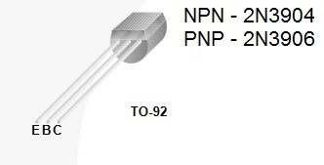
3 – 1 kΩ resistors
1 – 5.1 kΩ resistors
1 – 10 kΩ resistors
1 – 51 kΩ resistors
1 – 100 kΩ resistors
1 – 4.3 Ω resistor
2 – 100 Ω 1 W power resistor
1 – 33 Ω 2 W power resistor
3 – 22 Ω 2 W power resistors
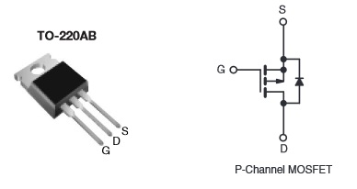
1 – 12 V DC Fan. (Note: There are not
enough fans for each group, so those available need to be shared).

Figure 1: Pin Definitions of transistors used in the Switched 12 V lab.

The circuit to be implemented in this lab is illustrated below in Figure 2. Referring to Figure 2, p-channel MOSFET (M1) is used to switch the 12 V on and off between V_{supply} and the SW12V output. Transistor Q1 is used to turn on and off the P-Channel MOSFET (M1), by means of the V_{on/off} supply, which could be implemented with a 0 to 3.3 V output available from a microcontroller digital I/O. The V_{on/off} supply is to be implemented with the VirtualBench adjustable +6 V supply set to +3.3 V for the on condition of the switched 12 V circuit. Because of the 10 kΩ pull-down resistor R1, simply disconnecting the V_{on/off} supply from the breadboard will turn off the switched 12 V circuit, as will setting the V_{on/off} supply to 0.00 V. The V_{supply} is to be implemented with the VirtualBench adjustable +25 V supply set to +12 V. Referring to Figure 2, with V_{on/off} = 3.3 V, transistor Q1 is turned on, lowering the voltage V_{a} to approximately 1.0 V, resulting in the gate (G) terminal of transistor M1 also equal to approximately 1.0 V. MOSFET transistors exhibit extremely high input resistance/impedance at the gate terminal, meaning that no dc current flows through protection resistor R6 into the gate terminal of the MOSFET. For the p-channel MOSFET in Figure 2, a gate voltage of 1 V and a source voltage of 12 V results in a source-to-gate voltage of approximately 11 V, causing MOSFET M1 to act like a closed switch with less than 0.5 Ω between the source (S) and drain (D) terminals. This corresponds to the SW12V output approximately equal to 12 V for loads requiring < 100 mA. As the voltage V_{a} increases from 1 V towards 12 V, the resistance between the source (S) and drain (D) terminals of the MOSFET increases, until the p-channel MOSFET eventually becomes open switch. With V_{on/off} = 0 V, the voltage V_{a} = 12 V with p-channel MOSFET M1 acting like an open switch, corresponding to SW12V = 0 V. Diode D1 is a Transient Voltage Suppressor (TVS) diode, used to clamp excessive voltages that occur when the fan motor current is abruptly changed. TVS diodes are essentially rugged Zener diodes commonly used for circuit protection.
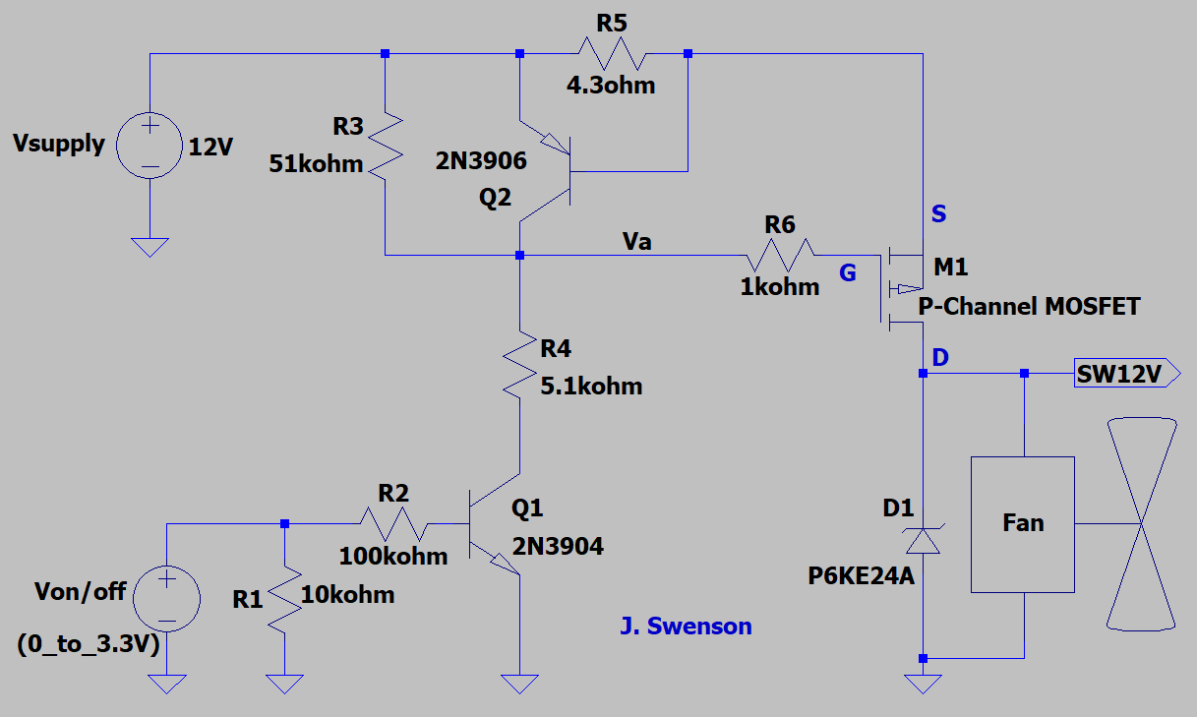
Figure 2: Switched 12 V Circuit.

P-Channel MOSFET M1 is essentially a voltage-controlled switch, with the source-to-gate voltage being the controlling voltage. For source-to-gate voltages greater than 6 V, p-channel MOSFET transistor M1 is fully turned on, i.e., a closed switch, with an on-resistance < 0.25 Ω. For source-to-gate voltages less than 2.5 V, enhancement mode MOSFET M1 is turned off, i.e., an open switch, and SW12V = 0 V. The pnp current-limit transistor Q2 starts to turn on, i.e., conduct non-negligible collector current, for a voltage across R5 of approximately 0.66 V, which is a more accurate approximation for this circuit than the 0.7 V turn on voltage approximation often used for hand calculations. As a result, for a load current sufficient to induce a 0.66 V drop across resistor R5, pnp transistor Q2 turns on which causes the voltage V_{a} to increase, which in turn increases the source-to-drain resistance of MOSFET M1. Consequently, the maximum load current provided by the switched 12 circuit is approximately (0.66 V)/(4.3 Ω) = 154 mA, by means of the well-defined V_{BE} turn-on voltage of a bipolar junction transistor.

Procedure:

- Breadboard the Switched 12 V Circuit of Figure 2. The pre-made jumper wire pins can be directly inserted into the 2-pin connector associated with the 12 V DC fans
- With a 12 V DC Fan as a load, verify the on-off functionality of the switched 12 V output circuit and then complete Table 1 below, using three significant figures for the measured output voltage. Be sure to include units for V_{O}, either by adding them to the column label or to each table entry. (4 points.)
Table 1: Switched 12 V Circuit Functionality.
V_{on/off} | SW12V | Fan State (On/Off)
0.00 V | 0.0 V | Off
3.30 V | 11.93 V | On

- Next remove the 12 V DC fan and connect 1 kΩ resistor R_{L} from SW12V to Ground. Set V_{on/off} = 3.30 V to enable the switched 12 V output. Then characterize the output voltage versus output current of the Switched 12 V Circuit utilizing several different values for load resistor R_{L} and measuring the resulting output voltage and V_{a} voltage, using at least three significant figures. Calculate the resulting load current or each of the various R_{L} values of Table 2 as I_{L} = SW12V/R_{L}. This Ohm’s Law approach to determine the load current is preferred over measuring the current with a series ammeter, as the ammeter adds an additional series resistance. Be sure to include units in your Table 2 data, either by adding them to the column labels or to each value. (15 points.)

It is recommended that you disable your switched 12 V circuit simply by disconnecting the V_{on/off} supply from your breadboard when you are changing out load resistor values, providing for safety along with allowing the p-channel MOSFET to cool off between measurements. Be cautious as the resistors and p-channel MOSFET will get hot to touch for load resistor values less than 500 Ω when completing Table 2.
Standard available resistors are only rated for 0.25 W, which is exceeded for a 21 mA load current from a 12 V supply. Power resistors (≥ 0.5 W) of value 100 Ω, 33 Ω, 22 Ω and 4.3 Ω are available in the STC 215 parts bins to aid in this output voltage versus load current characterization. Do not try and insert the leads of 33 Ω and 22 Ω power resistors into the breadboard holes, as these leads are too large. Instead use either alligator clip test leads or strip available telephone solid conductor insulated hook-up wire back an inch or more to connect to the 33 Ω and 22 Ω power resistors. Also, do not bend or twist these large leads together to connect them as they are then difficult to use again. Instead, separate Alligator Clips can be used to connect the large diameter lead power resistors in series, as shown below in Figure 3. Please straighten any leads that have already been bent or twisted together.
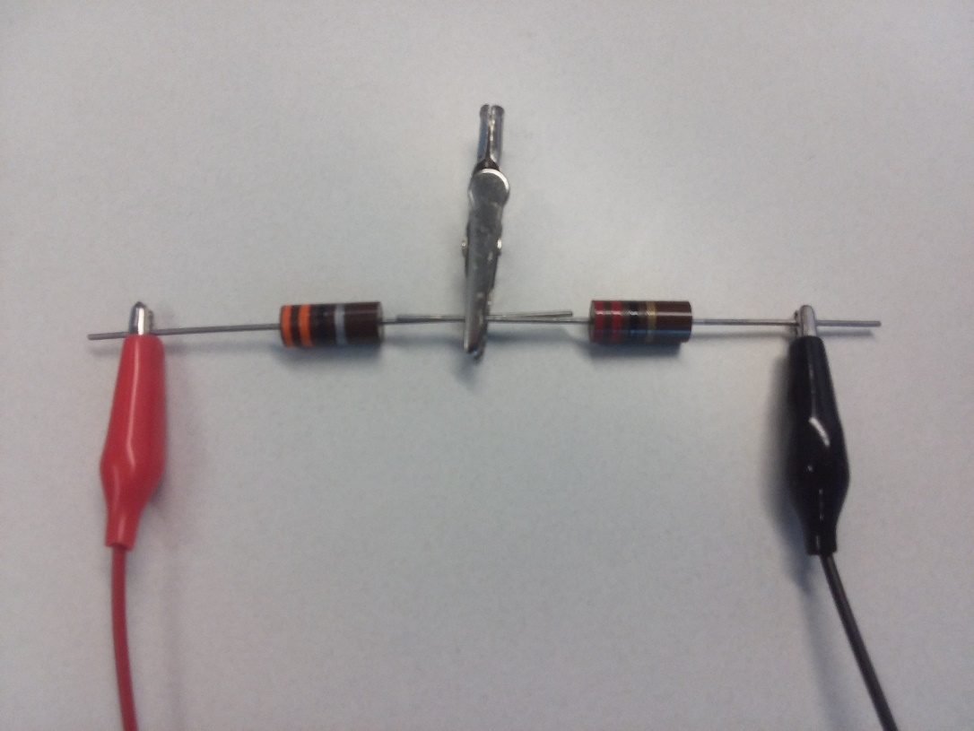
Figure 3: Illustration of Connecting a 33 Ω Power Resistor in Series with a 22 Ω Power Resistor to provide a 55 Ω Load.

Table 2: Measured Data for 12 V Output with V_{BE} Current Limit.
R_{L} | SW12V | I_{L} | V_{a}
∞ | 12.02 V | 0 A | 1.13 V
1 kΩ | 12.02 V | 12.02mA | 1.13 V
(1 kΩ)ǁ(1 kΩ) | 11.95 V | 23.9 mA | 1.13 V
Power Resistors: 100 Ω + 100 Ω = 200 Ω | 11.72 V | 58.6 mA | 1.13 V
Power Resistor: 100 Ω | 11.43 V | 114.3mA | 1.14 V
Power Resistors: 33 Ω + 22 Ω + 22 Ω = 77 Ω | 11.29 V | 146.6mA | 2.65 V
Power Resistors: 22 Ω + 22 Ω + 22 Ω = 66 Ω | 10.09 V | 152.88mA | 7.28 V
Power Resistors: 33 Ω + 22 Ω = 55 Ω | 8.71 V | 158.36mA | 7.31 V
Power Resistors: 33 Ω | 5.24 V | 158.78mA | 7.34 V
22 Ω | 3.448 V | 158.78mA | 7.380 V

- From your measured Table 2 values, plot SW12V on the y-axis with I_{L} on the x-axis. Add axis labels of “Load Current (mA)” for the x-axis and “SW12V (V)” for the y-axis, along with a title of “Switched Output Voltage versus Load Current – yolur name/names” to your plot as shown below. Replace the following graph of SW12V versus I_{L} with your version, including a figure number and caption. (5 points.)
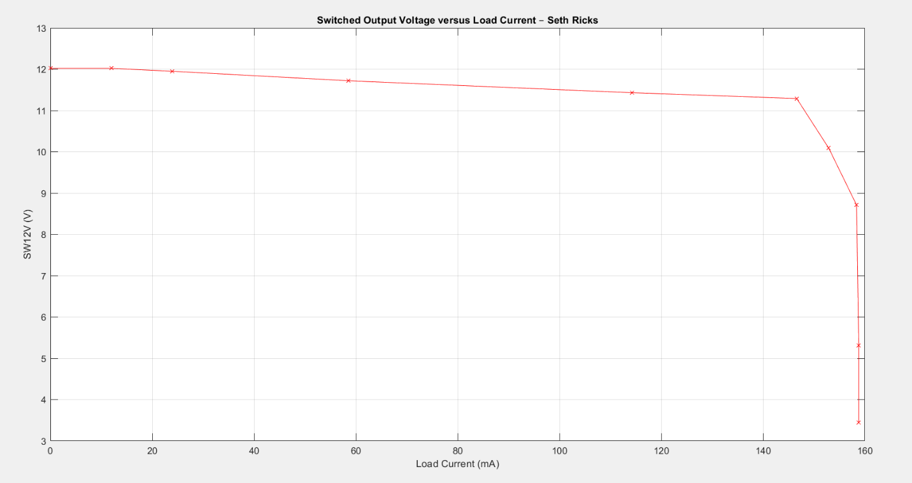
Figure 4: Output Voltage versus Load Current for the Switched 12 V Circuit.

Discussion and Conclusions Questions: (For the following questions use your own words along with complete sentences. Points are to be deducted for AI generated answers.)

- Explain how the V_{BE} current limit implemented in this lab functions, observing from your Table 2 data that the voltage V_{a} increases with increasing load current at the onset of current limit operation. (Note: The resistance between the source (S) and drain (D) terminals of p-channel MOSFETs like the one used in this lab decreases dramatically as the gate (G) voltage becomes more negative than the source (S) voltage.) (8 points.)
When the current is not too high, or it is below 0.7 V /4.3 ohm, then Q2 is not turned on. When the load resistance goes down, the current goes up. This means that the current through R5 will increase, and when the voltage across it is high enough to forward bias Q2, or 0.7 V, Q2 will turn on. When that happens, it will conduct more current to the gate of the PMOS, raising the gate voltage and lowering the current through the PMOS. This means that it will slow the current through the PMOS, because it needs a negative signal to turn on. This will decrease the current through the load. This makes a current limiter of 0.7 V / 4.3 ohm, which is about 162.8 mA. This is reflected in our table, as our current is limited to around 160 mA.

- What value for resistor R5 would you choose to implement a current limit of approximately 200 mA? (2 points.)
$$\frac{0.7 V}{200 mA}=3.5 Ω$$
$$R5= 3.5 Ω$$

- The Figure 5 schematic below is a circuit approximation to the switched 12 circuit with p-channel MOSFET M1 acting like a closed switch without any current limiting circuitry. When powered with 12 V, p-channel MOSFET M1 has a source-to-gate voltage of approximately 11 V. From the IRF9640 p-channel MOSFET data sheet, the transistor has a 62.5 ˚C/W thermal resistance in the TO-220AB package used in the lab, and a resistance between the source (S) to drain (D) terminals of approximately 0.4 Ω with 12 V source-to-drain voltage and 11 V source-to-gate voltage. Assuming a 0.4 Ω source (S) to drain (D) resistance, along with a healthy 12 V lead-acid car battery (> 300 A) for V_{supply} in Figure 5 below, calculate the theoretical increase in the junction temperature i.e., ∆T = R_{θJA}P_{D}, of p-channel MOSFET M1 if the SW12V output were accidently shorted to ground. Then briefly describe what you think would happen to the transistor during an accidental short. (Note: The calculated junction temperature should be a surprisingly large number.) (4 Points. 3 points for calculation, 1 point for brief explanation.)
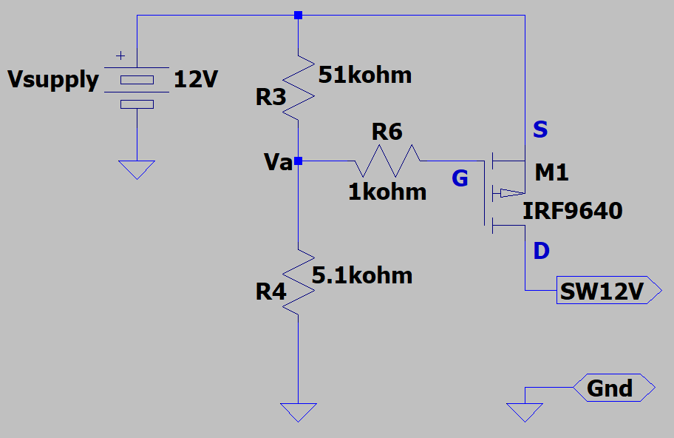
Figure 5: Switched 12 V Circuit with Switch M1 Turned On and No Current Limit.

$$P=\frac{V^{2}}{R}=\frac{{12}^{2}V^{2}}{0.4Ω}=360 W→360 W*52.5 °\frac{C}{W}=22,500 °C$$
Given this outrageously high temperature, the MOSFET would be destroyed almost instantaneously.

- Other forms of overcurrent protection besides the V_{BE} current limit used in this lab include one-time blowable electrical fuses, like those used in automobiles, and resettable circuit breakers, like those used in the AC electrical distribution system of modern homes. Describe both a one-time blowable electrical fuse (3 points) and a resettable circuit breaker, including what needs to happen to restore circuit operation after these devices are activated. (3 points.) (6 points total.)

An electrical fuse uses a thin piece of wire with a low melting point. When the current reaches a certain point, the wire melts, creating an open, and protecting the circuit. When a fuse blows, it can’t be fixed. It needs to be replaced with another fuse.

With a circuit breaker, the current goes through a wound coil. This coil will become an electromagnet if it conducts a certain amount of current, which flips a switch. This switch acts like an open, protecting the circuit from too much current. This means that you will have to manually flip the switch to turn the circuit back on.

Switched 12V with Current Limit Lab Grading Rubric: Submit an electronic version of a lab report to receive credit for doing this lab. The goal of your lab report is to provide sufficient documentation so that the lab can be repeated if necessary. Therefore, simply add to this document to arrive at your lab report, as all of the explanatory text, procedures, and Discussion and Conclusion questions contained in this document are required for a complete lab report. So, for your lab report, add a cover page that includes name or names, class and name of the lab. Also add in your results, and answers to the Discussion and Conclusions questions to the existing lab document. While you are to share all Procedure items with your lab partner if you worked in a pair, your Discussion and Conclusions section is to be uniquely yours and not a copy of your lab partners. The rubric below does not need to be included in your lab report.
Lab Report Item | Points
Cover Page | 2
Reasonable Table 1 values with units. (1 point per entry, -0.25 points for each missing unit. Units simply added to column headings is fine.) | 4
Reasonable Table 2 values with units. (0.5 points per entry, -0.1 points for each missing unit. Units simply added to column headings is fine.) | 15
Figure 4 Graph of Output Voltage versus Load Current including Figure number and caption. (5 points total, 2 points for properly plotted SW12V versus load current values, 1 point for x-axis label including units, 1 point for y-axis label including units, 1 point for title including your name/names.) | 5
Discussion and Conclusions | 20
Grammar and Professionalism | 4
Total | 50

Please give feedback on errors you find in this document.

